International Journal of Language Education
Volume 7, Number 2, 2023, pp.
ISSN: 2548-8457 (Print) 2548-8465 (Online)
Doi: 0000-0001-9730-9167

On awakening youngsters to foreign languages and their motivational disposition

Mohamed Ridha Ben Maad
Institut Supérieur des Cadres de l’Enfance, University of Carthage
ridhamaad@hotmail.com

Received: 3 April 2023
Reviewed:
Accepted:

Abstract
The study reported presently examined whether early exposure to foreign languages is propaedeutic to motivation for their learning in an instructed context. A two-scale questionnaire was specifically designed to study (i) the quality and amount of such exposure in the formative years of 321 primary school pupils and (ii) its bearing on their motivational disposition. Results suggested that exposure to foreign languages, or the lack thereof, had a strong influence on their motivational orientations. Substance for such correlation may encourage stakeholders to bank on early exposure to foreign languages within a child-pedagogically-friendly framework, namely the awakening-to-languages approach.

Keywords: Early childhood; foreign languages; motivation; exposure; awakening to languages; pedagogy

Introduction
Interest in English as a foreign language (EFL) has been gaining ground in early childhood education (ECE) worldwide. This sector of education already caught the attention of applied linguists decades ago although such interest was wavering at times. More recently though, it has turned into a “Cinderella area” of research as evidenced by the in tandem with a mounting socio-political pressure to learn foreign languages from an early age (Copland, Garton, & Burns, 2014). There grows a ubiquitous awareness of the benefits of such experience to youngsters, not only academically but also in terms of personality growth. From a scholastic end, early foreign language learning (FLL) helps children improve a matrix of (sub)skills attendant to problem-solving, comprehension, and communication. From an educational end, it comes with gains for children at a particularly vibrant developmental stage of their lives, hence in shaping their attitudes towards more understanding of, curiosity about, and receptiveness to cultural diversity.
According to de Botton (2010), these two ends actually coach on two major philosophical approaches in ECE: a positivist teacher-led approach championing literacy and numeracy and a socio-cultural, child-directed approach premised on the concept of growth rather than accretion. Pre-primary curricula fall somewhere between the two strata, all depending on the epistemological orientations of the designer as well as the agenda of the stakeholders. Despite the dominance of the teacher-led legacy due to social pressure to acquire languages at ever-earlier ages, the child-directed approach has been gaining eminence among academics and practitioners in their effort to explore and implement ideas related to learner agency. Most notably, the Asian context was not an exception given the bulk of studies attendant to this research pool as (Lin, 2013; Meisani, Hamied, Musthafa, & Purnawarman, 2020; Zein & Butler, 2022).
Among such academic efforts geared to the child-directed approach is the theoretical framework of Awakening to Languages which was pioneered by Hawkins (1984) and adopted by the Council of Europe and adapted to the pedagogical mainstream of plurilingual education policy. The particularity of this approach is to operationalize the construct of exposure in a principled and researchable way so much so that exposure to foreign languages may account for several benefits in terms of learnability and personality building. In fact, youngsters’ motivation for FLL is far from viewed as a direct outcome of external factors (e.g., tasks, teaching method, social class) but rather as a long self-regulated process fed the presence/absence of negative/positive factors (Dörnyei, 2005) that would later determine one's motivational temperament . In this purview, the present study was designed to examine whether early exposure to EFL may play a consequential role in one’s motivational disposition to learn it later in an instructed context. In this purview, the significance of this study accentuates the following highlights:
· There is more to teaching languages at ever-earlier ages than acquisition.
· Early-years exposure to languages may affect motivational disposition in the long run.
· The child-friendly pedagogy of awakening may offer more possibilities to learners.
· The need to revisit mainstream pedagogical practices geared to early-years language education.

Literature review
Early-years FLL
The situation of ECE in Tunisia is characterized by a lack of vision in the absence of a research-sustained curriculum (Ben Maad, 2014). Whereas the role of the state is basically regulatory and responsible for educator training, ECE has been fully dominated by the private sector that operates under no particular supervisory power over what and how to teach. Although promoting FLL has garnered attention among Tunisian academics and pedagogues geared to advanced levels of education in matters related to planning, evaluation, and training, no such interest has been equally considered by ECE stakeholders. The latter’s interest in FLL is merely justified by the parents’ desire to have their children learn, particularly, French and English and thus acquire a solid groundwork for their education at later stages (Ben Maad, 2014). In this respect, their take on FLL, far from being research-informed, aligns with a product-oriented view that does see learning a given language as an achievement process of a literacy course and not as another opportunity for personality building.
One issue attendant to early-years FLL consists in the absence of specialized training for educators which in turn reflects hardly any sense of perspective based on serious research-informed questions about why, how, and when youngsters should embark learning a foreign language. It is nonetheless fuelled by today’s hegemony of a market-value system that underscores the values of efficiency, excellence, productivity, etc. The zeitgeist for such values justifies a commonplace pedagogical stance based on an essentialist and form-focused idea that that simplistically reduces language to some compartmentalized and discrete areas of vocabulary, grammar, and sounds to be mastered with peripheral interest in its cultural substance (Abid, 2012). At this juncture, the role of the ECE educator would consist in transmitting this form of knowledge/skill in a normative way would expedite the language assimilation process and, eventually, turn children into accomplished achievers (Copland et al., 2014). The Asian context does not make an exception. In her reflection on the Hong Kong experience, Lin (2013) concluded that despite some locally plurilingual pedagogies were advanced by some innovative, yet negligible number of scattered experiences, “deep-rooted ideologies of linguistic purism combined with dominant TESOL knowledge claims have made it difficult to develop locally appropriate methodologies” (p. 521).
In fact, early-years FLL lends itself to a product-focused frame of mind which inheres a market-minded view of citizenship (Lin, 2013). That is, a good command of a given foreign language would secure for children better chances in the job market, hence turning into ‘achievers’ How much that FLL experience might enrich and hone their personality would be at the bottom of the stakeholders’ priority list. Nonetheless, with the turn of the 21st century, a new educational discourse has been gaining currency among scholarship that embraces an active form of global citizenship among its projects. Education is therefore purported to help youngsters develop the knowledge, skills and values whereby they can position themselves in a now culturally pluralistic world. Serious research projects were therefore conducted by the Council of Europe to promote plurilingualism in FLL through a number of pedagogical alternatives (e.g., the awakening-to-languages approach). The Tunisian ECE experience may build on these innovations provided that it undergoes serious revisions in this vein.

Awakening children to FLs
Anchored in pedagogy of discovery and inquiry, the awakening-to- languages (ATL) approach gives primacy to experiencing languages –and the cultures therewith– over the literacy side (Ben Maad, 2016; Candelier, Daryai-Hansen, & Schröder-Sura, 2012; Lourenço & Andrade, 2013). Its main tenet to experience rather than learn (about) languages does not conceptually consort with the prevailing proficiency-focused models of teaching FLs. Reasons for such hegemony relate to globalization as cultural crossovers make it a necessity to learn FLs, and learn them fast. Nonetheless, ATL has received particular attention from lead educational institutions, as with the Common European Framework of Reference for Languages: Learning, Teaching, Assessment guidebook which draws attention to the importance of equipping “all Europeans for the challenges of the intensified international mobility [and] to promote mutual understanding and tolerance, respect for identities and cultural diversity” (p. 346).
Also, the ATL approach can be considered as a full-fledged pedagogical candidate for enriching early-year FLL. As such experience has been garnered by the consideration of working with youngsters, hardly any solid constancy has been documented within the research attendant to it (de Bot, 2014). The downside here is perhaps latent in the nature of the dominating proficiency-based approach in mainstream research in its quest to quantify achievement. Yet, the ATL approach represents a pedagogically-approachable view not only through its goals but also its expediency. Based on principled exposure to FLs, this pedagogical alternative engages age-appropriate ways of learning through sight, sound, taste, touch, smell, and doing while they embark on comparing and reflecting on the cultural values of the culture behind a given language.
The ATL approach has been given substantial consideration by educational circles across Europe through the emergence of government-supported projects (e.g., FREPA, Evlang, and JaLing) engaging numerous curriculum designers, language teachers, and test developers (see Candelier et al., 2012). All this effort transpires a political willingness to grapple with the now culturally heterogeneous fabric of urban life through the promotion of values of tolerance and openness and establish social harmony as a sustainable asset for the collective welfare (Fatima, Ismail, Pathan, & Memon, 2020). Nonetheless, introducing this educational enterprise in culturally-homogeneous societies, such as Tunisia, is squarely different. The weight of globalization on such developing countries has occasioned adverse forms of resentment and “othering” ranging from chauvinism, xenophobia, fundamentalism to violent acts of terrorism. Yet, beyond the old national natural boundaries both the new physical and virtual encounters are not necessarily skewed towards adverse response patterns but rather shuttle between forms of “seduction or confrontation, discovery or recovery, desire or loathing, wonder or disillusionment, peace or war” (DeSousa, 1999, p. 2). Fixing the pendulum onto the positive response patterns would rely on a principled application of a plurilingualism whereby any educational platform—contingent on the ATL approach— may instill the values of tolerance and openness through providing children with an appropriate pedagogical diet.
Researchers studying the ATL approach have referred to both learning and transformative benefits for young learners. Linguistically-wise, Lourenço and Andrade (2014) suggested that such pedagogical approach may enhance children’s metalinguistic awareness of a given language and strengthen their aptitude. For instance, their acquired awareness of its phonological patterns would enable them to “crack the code” of its alphabetic system through their boosted “ability to recognise, distinguish, and manipulate the basic sound structures of a language, such as syllables and phonemes'' (p. 4). Also, the ATL-based experience may well widen their knowledge repertoire about the target languages and their wiring systems which, according to Kuo and Anderson (2010), may allow them to formulate approachable representations of such language structures. At the transformative level, Azaoui (2012) emphasizes a substantial role for ATL experience in children’s openness to diversity and receptiveness to cultural differences. They would therefore engage in a discourse of openness which energizes their sense of empathy, understanding and tolerance (Azaoui, 2009; Candelier& Macaire, 2001; Candelier et al., 2012; Fatima et al., 2020). With an ATL-driven exposure to assorted languages, children may develop a reflective understanding of the world and themselves that can see things and others beyond the confines of their native cultural bottleneck.

Motivation and FLL
The concept of motivation has been explored in a variety of disciplines such as organizational psychology, economics, and education. It has also captivated the attention of applied linguists, hence producing a rich literature accentuated by main approaches that do not cease to inspire extant scholarship and FLL pedagogy (Dörnyei & Ushioda, 2011; Jiao, You, & Young, 2022; Lamb, Csizér, Henry, & Ryan, 2019). In this respect, the 1990s witnessed an abundance of motivation research in FLL literature associated with the emergence of several influential models. Among the featured models which addressed the situated part is Dörnyei’s (2000) view of motivation as a dynamic process which evolves in a three-phase cycle of generation, maintenance, and retrospection. Hence, the situation-specific motives (i.e., task, teacher, learner group, etc.) may override one’s attitudinal disposition towards a foreign language. Equally, several FLL researchers have increasingly subscribed to the idea of motivation as the outgrowth of a self-regulatory process. Ushioda (2003), in this respect, refers to motivational self-regulation skills as a set of internal processing, monitoring, and filtering tools that outline the direction and the growth of learners’ motivational outlook. Unlike those unable to regulate their motivation, skilled self-regulators are able to maintain their motivation in the face of trying and/or distracting variables. Also concurring with the idea that motivation emanates from within, Dornyei (2005) refers to an L2 motivational self-system which controls our motivational mechanism, particularly of the individual’s representation of what s/he might become, what s/he would like to become, and what s/he is afraid of becoming. It is within this framework that youngsters envisage the silhouette of their learning experience, towards the fulfillment of their projected L2 ideal self (Roshandel, Ghonsooly, & Ghanizadeh, 2018).
As for the present study, the configuration of motivation dwells on two parameters: causal (i.e., associated with learning-related factors) and teleological (directed towards short/long-term goals) (Ushioda, 2001). The latter part, however, does not seem to captivate due scholarly attention despite its theoretical substance. In fact, not much has been explored to chart evidence for the teleological aspect in the light of the paucity of FLL motivation research targeting the ECE sector. The issue goes far beyond this area of research to concern a whole tradition of seeing adults as typical research subjects, or else approaching children based on methods characteristically used with adults (Pinter & Zandian, 2014). Examining the propaedeutic contribution of early FLL experience to one’s subsequently established motivational disposition may not only draw attention to this research oversight, but also provide enough incisiveness for educational stakeholders to tackle the issue of FLL motivation proactively. Insights from early exposure to foreign languages within the awakening pedagogy seem to add up much to this picture.
Within the scope of this paper, ATL accords with the motivational constructs of self-regulation and the self-concept when it comes to early FLL. Like any other learning experience when an authoritarian style prevails, children adopt a conservative people-pleasing pattern of learning while being aware of the inherent power relations and the peculiarity of group dynamics in their family background (Desforges & Abouchaar, 2003). They would therefore deactivate any possible self-regulatory processes (goal-setting, self-evaluation, etc.) to conform to the reward-system established by their parents/teachers. Alternatively, an ATL-based exposure to FLs would reinforce such processes in view of a process-oriented task completion, so much so that youngsters would be able to individuate their FLL course. Not only do they hold on to the transformative –instead of the proficiency-focused– side of the FLL experience, they may well ward off negative motivational reflexes of avoidance (Ben Maad, 2012; Dweck, 1986; Tercanlioglu, 2004) typical of other-regulated learning (i.e., measuring one’s success/failure against external achievement levels of others).
In this purview, intrinsic motivation may accrue throughout an advantageous learning environment wherein youngsters proactively set goals of what (not) to learn. The silhouette of their self-system would crystallize accordingly, with nascent possible selves seeing achievement in the discovery of and interaction with the target language(s). As a matter of fact, it is either through ATL-focused plurilingual programs or informal exposure to FLs that even preschool-aged learners may develop a motivational basis for their future instructed FLL experience. This may appear both at the attitudinal level and the behavioral level. On the one hand, changes in their attitudes would readily feature the way they view the world beyond the inner circle of their cultural space. On the other hand, motivation would resurface their behavioral routines as with their persistence for FLL (Dörnyei, 2000) which, according to Constantin, Holman, and Hojbotă (2012), the “tendency to remain engaged in specific goal-related activities, despite difficulties, obstacles, fatigue, prolonged frustration or low perceived feasibility” (p. 99). Accordingly, this phenomenon stands out in three types of pursuing during task engagement: current purpose pursuing, long-term purpose pursuing, and recurrence of unaccomplished past goal pursuing. Another behavioral feature of motivation worth-considering here is the willingness to use which has the same conceptual properties of the well-documented concept of willingness to communicate (MacIntyre, Dörnyei, Clément & Noels, 1998; MacIntyre & Wang, 2021), except that the former involves not only interaction but also the commitment to any kind of exposure (e.g., listening to radio, remembering an intercultural event, etc.).
Overall, based on (i) a teleological view of motivation (with its attitudinal and behavioral features) and (ii) an ATL framework, the present was set to verify whether exposure to foreign languages affects youngsters’ motivational disposition for learning foreign languages in later educational stages.

Research method
Participants
Three-hundred and twenty-one primary-school pupils took part in this study (Age M = 10 years and 4 months; Males N = 146; Females N = 175). They represented a linguistically homogeneous group –being all native speakers of Tunisian Arabic and Modern Standard Arabic as the official language of instruction (Ben Maad, 2014). They came from both urban (N = 182) and rural (N = 139) areas and were enrolled in five public schools wherein English classes became mandatory from Grade Five, yet without following a particular FLL. The participants were indiscriminately chosen upon the formal consent of their parents who had mixed levels of education and belonged to diverse social strata (i.e., a clear gulf between those coming from affluent suburbs and poor rural areas in the southern part of the country). It is also crucial to point out that the educational system which engages these participants encourages bilingualism. French still occupies a prominent consideration due to the historical and economic ties with the then Colonial France. In addition to these young informants, five research assistants helped with data collection and instrumentation. Aside from being the present teachers of the main informants, they assisted with (i) refining the scales by advising on and rating the scale content (ii) and administering the questionnaire to their pupils during regular classes. They also trained on matters of ethics and treatment related to researching children based on guidelines from Lobe, Livingstone, Olafsson, and Simões (2008).
It follows that the sampling process experienced several modifications before fixing to the ultimate group of participants. Because of the susceptibility to treat young individuals as research subjects, anticipated concerns as to response consistency and the intellectual limitations vis-à-vis the psychometric instrument were fully considered and put under scrutiny. The second step was to conduct a pre-posttest design based on the same sample of the latter study. Actually, the participants were feared to scatter among other primary schools, hence any possibility to proceed with them could not be guaranteed. It was ultimately felt more reasonable to opt for a relatively homogeneous sample with a clear variation regarding the extent of exposure to FLs, making the required comparison according to such variables fairly manageable.

Design of the study
In examining the hypothesis that early exposure to FLs has a propaedeutic influence on a child’s motivational disposition felt in later stages of his/her schooling, the present study embraced correlational analysis. It drew on psychometric measurement to explore the relationship between target variables to determine the size and causal direction of such correlation. Following an observational data collection process, focus was directed at two types of attributes: a foreign-language exposure (FLE) attribute hypothesized to be the explanatory variable and a motivational attribute treated as the response variable.
The FLE variable was operationalized to document participants’ handling of the learned languages in their formative years. That experience extended from their family environment, through formal settings such as preschool, to public areas/events where FLs should be used. The response variable of motivation was treated according to three dimensions: (i) the informants’ attitudes towards FLL, (ii) willingness to use (WTU) foreign languages in (in)formal contexts, and (iii) persistence of FL use. The choice of this motivational triad was intended to provide a multi-faceted representation of motivation. Whereas the attitudinal aspect accounts for how individuals view FLL, WTU measures the behavioral commitment to such views. WTU bears on the well-cited L2 willingness-to-communicate construct (MacIntyre et al, 1998; Fatima et al., 2020) but expiates ‘use’ for ‘communicate’ due to latter’s exclusiveness to those having some command of FL. The persistence dimension, particularly associated with Dörnyei’s (2000) within-task motivation, measures the endurance spent on difficult tasks and resistance to discomfort.
Also reported was a cursory appraisal of the proficiency level in English to detect expected correlations with their motivational outlook.[1] As such, positive correlations would further confirm the participants’ extent of motivation. Additional demographic variables of gender and age were included in the research plan to check whether the measured motivation would be equally susceptible to individual differences.

Instruments: procedures and validation
Both the variables of motivation and FLE were operationalized into two separate scales. The development of each scale proceeded in view of two major challenges. The first issue was with the lack of comparable measures in published research for the possibility of making replications and building on some external validity. The second problem ensued from the delicacy of doing research with young subjects. In view of that, scale development drew on suggestions from Lobe et al. (2008) on matters attendant to questionnaire building and implementation. To obtain sufficiently reliable data, all the items were formulated in a self-report style to be subsequently trailed by a response format based on a 3-point Likert scale along agree, not sure, and disagree options. Although it does offer such substance and variance as with higher point Likert scales, the present scaling was adopted to observe the intellectual exigencies of the young participants. For the similar purpose, the sequence of items followed a thematic line along a set of subscales since a random shuffle might upset their concentration.
After their conceptualization and construction, the scales in focus went through two phases of treatment to secure some more expediency. On the one hand, both scales were translated into the native language of the respondents by two of the research associates, translated again by two other assistants to be equated against the original output, and eventually, inconsistencies were fixed. On the other hand, the translated version was pilot-tested on a small sample of 5 students (sharing the same profile of the main participants). They would report the intelligibility issues with any given item to be reworded and/or and converted into structurally simple statements when necessary. Some statements were shortened to make the reading load less challenging for the participants. Subsequently, another round of piloting was carried out on them and no difficulty issues were raised henceforth. The one-time questionnaire distribution started with the announcement of the objectives to the respondents and a teacher-fronted demonstration about how to respond to the questionnaire. They were reminded that no compensation would be offered in terms of grading, nor should they write their names. When handing the response sheets, the research assistants, also their actual teachers, would code them for subsequent identification.[2] To further ward off the desirability factor, the participants were asked to deposit all the response sheets in a ballot box. After collection, only the correctly-completed questionnaires were considered for data-analysis.

The Exposure-to-FLs scale
The FLE scale was designed to measure the participants’ extent of exposure to FLs along the context triad of the family, early school, and community. The sixteen-item questionnaire was organized into four equal subscales, each measuring one aspect of such a relationship. Subscale 1 assesses how negative and/or positive the views of the entourage would stand out towards using EFL. Subscale 2 examines whether such attitudes would evolve into committed behavior by the child’s entourage. Subscale 3 measures how far the informants experience EFL usage through handy media technology. Subscale 4 extracts data about the respondents’ experience with events/locations (e.g., hotels, festivals, restaurants) wherein they would experience EFL as a tool of communication. According to the distributional data in Table, the assumptions of normality and homogeneity were not violated. For instance, homogeneity was observed across all the scale items given that their respective Levene's Test of Homogeneity scores proved to be non-significant, extending from p = .13 (Item 6) to p = -.95 (Item 16). Equally verified was the item-reliability index as all the items obtained alphas beyond the common .70 cut-off, with Item 7 being the lowermost (α = .72).
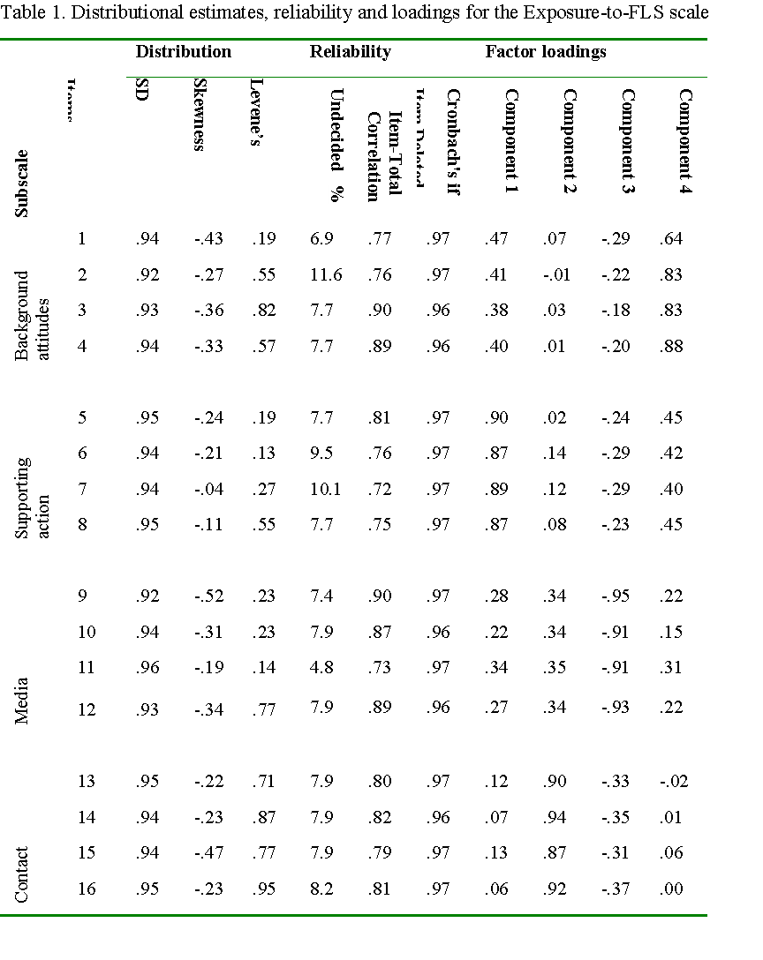
Upon confirming their internal stability, the overall items went through factor analysis using a Principal Component extraction method. It suggested a four-factor structure whose overall variance was up to 68.57 %. All the inter-correlations within each loading lot exceeded the acceptable .05 cut-off limit experienced in an exploratory research framework (Tabachnick and Fidell, 2001) (i.e., between r = .64 with Item1 and r = -.95 with Item 9). It follows from these findings that the present factor solution substantiates the construct validity of the subscales.

The Motivation scale
The 12-item scale sought to capture the respondents’ extent of motivation for learning/using FLL. Its first subscale appraises the level of motivation through youngsters’ views of FLL. Subscale 2 measures their behavioral profile vis-à-vis such motivation. Subscale 3 reveals how committed these individuals are to learning/using foreign languages in terms of their persistence in the face of difficulties and response to uncomfortable situations. According to Table 2, the assumption of normality was observed seeing the one-way negative skewness of the data that does not surpass the absolute level of 2.00/-2.00. In fact, the negative pattern of data distribution intimates that the majority of respondents scored high on motivation −a trend accentuated by an assorted percentage of undecided responses ranging from 7.9 % (Item 7) to 38.9 % (Item 6). Homogeneity results are not entirely solid despite the majority of the non-significant Levene's scores, a fact illustrated by the almost significant value p = .03 for Item 2. In view of the relatively accepted assumption results in Table 2, the item-reliability index suggests some inconsistency. In fact, only some of the present alphas are marked beyond the.70 commonly acceptable limit. Hence, 6 out of the 12 items were eliminated from further analysis. Such resolution did not opt for flexibility even with items approximate to the acceptable cut-off limit (e.g., α = .65 for Item 6) due to the lack of prior validation of the scale. It was felt safer to count on clearly high alpha scores to add more robustness to the data. This was confirmed by a re-test of the retained items which yielded an overall scale reliability of α = .91.
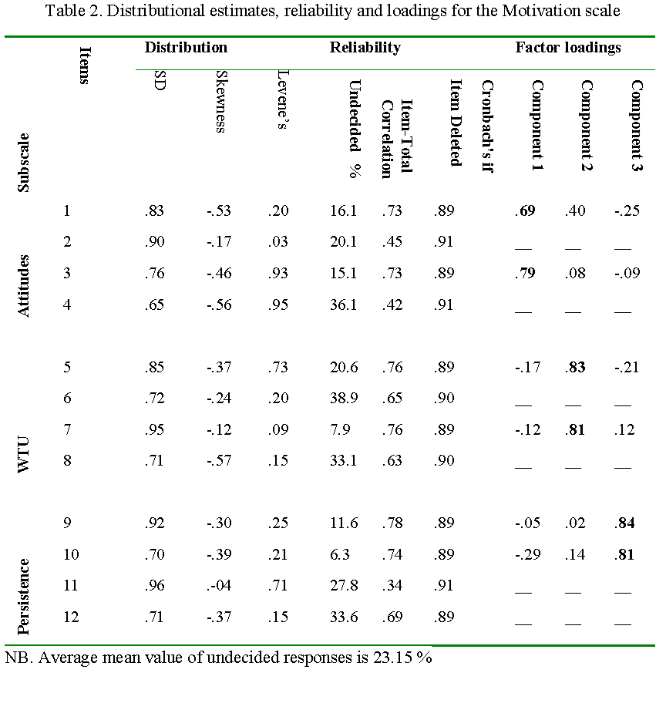
In order to check the factorability of the remaining items before their submission to factor analysis, their overall correlation scores across the purported subscales was corroborated (i.e., r higher than cut-off .30 level). Then, the application of the Principal Component extraction method resulted in a three-factor structure with a total variance of 64.12 %. The factor matrix reported in Table 2 displays three main loadings with high internal correlations, corresponding to the item groups purported to represent the three motivation subscales of attitudes, WTU, and persistence. It is worthy to note here that that Item 1 shows a score of r = .69, and also cross-loads with Component 2 (r = .40). Such cross-loading does not seem to be problematic given that it does not surpass the acceptable .50 level so as to be established as an integral part of the second Component. The three subscales have the same loading pattern of a positive high loading, a positive low loading, and a negative low loading each. In sum, the present factor solution, in the absence of the eliminated item scores by the reliability test, attests to the construct validity of the Motivation subscales.

An outline of the questionnaire
The questionnaire comprises two scale sets: the Foreign Language Exposure subscale and the Motivation for Foreign Languages subscale. The first subscale was purported to:
(i) Elicit information about the perceptions within the family regarding their children learning and using foreign languages (e.g., “My parents always encouraged me when I used English”).
(ii) Reveal whether these attitudes are validated by the family in the form of daily commitments, such as reading bedtime stories to their children in English and singing (e.g., “I sing in English and dance with my parents”).
(iii) Verify FL media accessibility when it comes to TV programs and cellphones (e.g., “I always see American films and cartoons”).
(iv) Elicit information about their hands-on involvement in events and venues, such as hotels and non-national restaurants where they experienced an intercultural contact (e.g., “I went to a birthday party and celebrated in English songs”).

As the second subscale revolves around their motivation for learning and using foreign languages, it was meant to:
(i) Measure the degree of their motivation by defining their attitudes towards learning such languages (e.g., “English helps me have friends from different countries”).
(ii) Check if their behavioral patterns are consistent with their willingness to experience foreign languages hands-on (e.g., “I always watch films and cartoons without captioning”).
(iii) Determine the extent to which these respondents were persistent and committed to experiencing/learning foreign languages when they met some difficulties in and off class (e.g., “I try to finish the tasks even when they sometimes seem difficult.

Results
To check for the hypothesized correlation between the informants’ exposure to and motivation for FLL in later stages of schooling, the analytical effort proceeded to test the inferences about the projected correlation.
Exposure and children’s motivation
The second part of the study addresses the hypothesized propaedeutic correlation between exposure to FLs and children’s motivation for instructed FLL. Before giving a quantitative account of such influence, it was crucial to perform a correlational examination on the FLE variables thought essential for the subsequent analysis of the multivariate results. In fact, three considerations were inferred from the correlations matrix (Table 3). First, Gender and Age showed low correlation with the rest of the variables, except for the latter being slightly, but inconsequentially, linked to the Media level. Second, the Exposure-to-FLs variables demonstrated reasonably significant inter-correlations, ranging from r =. 34 to r = .85. It is to note that such significance did not illustrate cases of multi-collinearity as none reached the r = .90 stratum (Tabachnick & Fidell, 2001: 82-85). Third, the informants’ proficiency level showed consistent association with the exposure factors. These findings suggest substantial correlation between all the exposure variables and the informants’ formative environment, most predominantly from the adult-based support area.
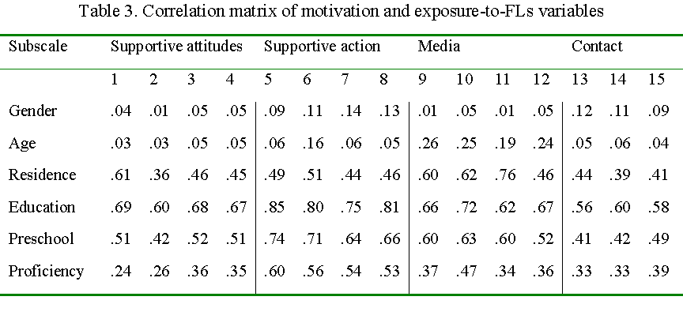
To verify the correlation between the informants’ FLE and their motivational outlook, data from the two scales went through MANOVA. Only retained for the analysis were those items checked for reliability and construct validity beforehand. It is also important to outline the effect size of the relationship between the exposure features and the sum of the motivation variables, Eta squared (η²) estimates were considered. The effect size is the amount of variance in the dependent variable of a given effect. To start with, despite their apparent significance, Gender and Age did not seem to bear much on the participants’ affect for language learning, as evidenced by the slim effect size with Partial η² =.11 and Partial η² =.12, respectively. Contrarily though, results for the Exposure-to-FLs subscales suggest significant differences translated into statistically satisfactory eta² values. According to the recommendations of Tabachnick and Fidell (2001: 54), the corresponding eta² scores range from (i) acceptable as to Residence (η² =.49) and Preschool (η² =.66) and (ii) large as to Education (η² = .81). In sum, findings from Table 4 attested to the hypothesized correlation between the Exposure-to-FLs variables in and the motivational disposition of the informants, especially when it comes to the Education determinant which garnered the biggest share of correlation. Contrariwise, although the F test showed significant correlation between their motivational disposition determinants and the individual variables of gender and age, the eta squared results do not strongly confirm that correlation. This inheres. Building on the strong correlation results of the exposure variable, it still remains important to determine the direction of that effect pattern in the subsequent analysis.
Table 4. MANOVA results for the Exposure-to-FLs effect on motivation for FLL
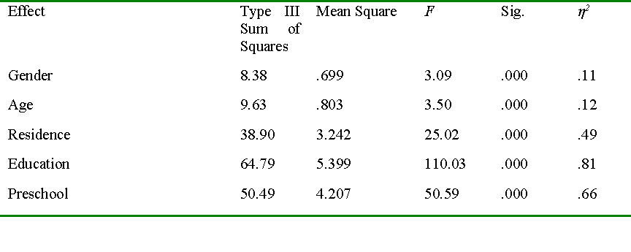
As a follow-up procedure to evaluate the nature of the significant difference (i.e., the effect direction being either positive or negative) a multiple comparison test was carried out. Descriptive data reported in Table 5 show a clearly positive causal pattern for the three exposure variables. Irrespective of the nature of variance (i.e., positive or negative) for one item against another, there appears no discrepancy in each subscale, where the scores for the two items representing each subscale attest to the same pattern of difference. It is worth reminiscing here that the choice of the items of each subscale was due to their internal loadings suggested by the EFA results in Table 2.
Those results attest to an outright advantage for the Education variable over the Preschool and Residence variables. The pair-wise mean difference values (MD) attendant to Residence demonstrate internal consistency within the three motivation areas that range between MD = .71 (Item 10) and MD = .39 (Item 1). That is, participants from rural areas, already having little chance of exposure to FLs, expressed less motivation for learning languages, most palpably in the Persistence area. As to the Education variable, the difference between its two levels is larger, especially when it comes to WTU and Persistence. Children raised in an educated entourage scored higher than those born to uneducated parents. In this respect, MDs are as high for Item 7 (MD = 1.28) in the WTU section and MD = 1.14 (Item 9) as to the Persistence area. A similar consistency applies to the Preschool variable where those receiving preschool education seemed to show more persistence in dealing with language learning difficulties than those who never attended preschool (MD = 1.03 for Item 9). This also applies to their WTU in and off class (MD = 1.05 for Item 7).
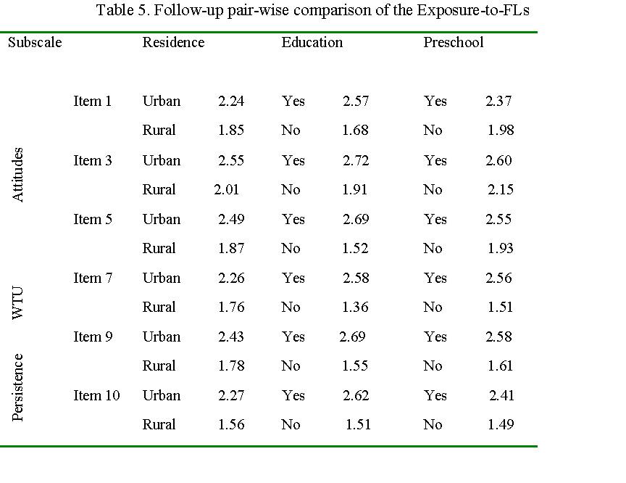
Discussion
The decision to report findings attendant to the reliability and validity of the two-scale instrument was deemed a necessary groundwork whereby the analysis of the main findings would seem sensible. Equally important to verify at the outset was whether the distributional assumptions of homogeneity and normality were satisfied, which was the case in the present study. If violated, the subsequent inferential analysis of variance would have been misleading and far from being reasonably interpreted (Keselman et al., 1998: 351). In this regard, the handling of exposure to and motivation for EFL measurements did not harm their consistency, and therefore their research worthiness in view of the delicacy of dealing with a young sample. Yet, caution is warranted since such results remain an estimate of the young informants which, irrespective of the guided effort here (Lobe et al., 2008), would remain particularly susceptible to their environment. Added to this call for cautiousness is that the quality of performance and rigor of the assistant researchers may turn upsetting, being all unfamiliar with this research experience.
One of the issues that the validation results happened to contain was related to the operationalization of the exposure variable. Some concern was raised regarding whether the background attitudes dimension might well interface with –and somewhat correspond to– the supporting action dimension. The results showed that item inter-correlations showed quite considerable values rising up to r =.47 for Item 1. Yet, the level and consistency of the intra-correlations within each subscale demarcated the divide, with a lowest of r = .64 for Item. Another issue worth raising here is the extent of indecision despite the favorable results attendant to the reliability of the two scales. In view of that, the percentage of undecided responses was fairly low for the Exposure-to-FLs scale (7.34 %), yet much higher for the Motivation scale (23.15 %). This finding may be of considerable insight to the researcher who may find some scientific value in such behavior (e.g., respondents being reticent to give negative feedback in an effort to please the fieldworker-teacher). Viewed from a validation perspective, however, may suggest some interesting intelligibility possibly embedded in formulation of the scale items. Overall, it is tenable to build on these salient validation results here although revisions are welcome to ease such concerns.
The main findings suggested a clear correlation between early exposure to FLs and the respondents’ motivation for later instructed FLL. Analysis of the data reported in Table 3 referred to a strong and systematic correlation between the aspects of exposure and the areas of exposure in terms of Residence, Preschool, and parents’ Educational background, and hence the Education variable garnered the lion’s share of the correlation sum. One reason to explain such an advantage is that the family environment would assume the biggest share of presence in the child’s life, unlike the time-constrained presence of preschool. For that reason, the Education variable, when associated with the parent as an agent of exposure, would outweigh the other variables in influence. There is an ongoing influence of the parents who naturally transmit their socio-cultural heritage, or in Bourdieu’s terms (1989), a symbolic capital, to their offspring. Those parents would belong to a social segment that treasures education including FLL, and so instilling academic values is not uncommon. This was no surprise when it loads the highest not only with Preschool but also Media since educated parents would be more conversant with media technology trends which would require some command of English. As such, they would exert every effort to prime their children’s academic attainment with regard to FLL.
Regardless of the amount and quality of EFL exposure at preschool, this institution would be accessible only for those whose parents can afford to enroll them therein added to the fact that it is not as well presented in rural areas as in suburbs. Overall, the palpable correlation between motivation for FLL and early exposure to some given language should not obscure the fact that precious information would be undocumented as with the literacy environment, the hidden agenda of each of the target preschools, group dynamics the informants were involved in, etc. Such information could not be documented due to the close-ended nature of the elicitation tool in the study and also the susceptibility to obtain that information from their parents unless complicated formalities were observed. Instead, this would have been possible had one case studied the sample as in a local context. In their account of the Iranian experience, Asgari and Mustafa (2011) reported a detailed behavior of parents from an educated background as the informal mediators for their children’s FLL.
In light of the findings reported in Table 4 and confirmed in Table 5, the variance in the respondents’ motivational disposition was operationalized into three measurement areas: attitudes towards, willingness to use, and persistence to engage in FLL. The resultant picture yielded two learner profiles: highly motivated urban former pre-schoolers (HM) from educated families versus poorly motivated rural individuals (PM) with either no preschool record or educated family background or without both. From a Self-based perspective (Roshandel et al., 2018), the HM respondents had most probably developed an early vision of the FL self in their formative years. Dörnyei and Ushioda (2011: 97) refer to the ‘ideal self’ as being a powerful motivator, consists of an “imagery/vision component that activates appropriate emotions and is cued to a variety of appropriate cognitive plans, scripts and self-regulatory strategies.” Findings here are in some way commensurate with this metaphorical image where the L2 ideal self matures with time (Ushioda, 2009; van Geert, 2011). In line with the results from the Attitudes subscale, the HM respondents voiced their prospects about the FLL course in a clear way. The FL self-perception they aspired to connect with accrued through the little details they picked from the long, and perhaps interrupted, course of exposure to FLs.
Their fledgling vision would give them a sense of purpose in their FLL course in tandem with a strong FL ‘ought-to’ that would immune such courses against upsetting factors such as fatigue and anxiety. Evidence of such self-concept figures in the findings reported in the Willingness-to-use subscale. Accordingly, the HM informants confirmed their sense of obligation and commitment to FLL through their own means. Watching uncaptioned cartoons did not discourage them from interacting with them as they would refer to self-regulatory strategies to grapple with the linguistic downside. Sure enough, the closed-ended nature of the elicitation tools could not reveal much about those strategies albeit insinuations might attest to that. A favorable reaction to the statement: When I learn English vocabulary I use it not only in class, it intimates his/her responsibility to secure the new knowledge set without any compulsion from the family or teachers.
Also revealed about the HM respondents –added to their high motivational disposition– was their intrinsically-oriented view of FLL. Although they did not dismiss the utilitarian value of FLL through their favorable response to Item “It is essential for my future career to speak English”), the significant results from the Persistence area substantiated that intrinsic proclivity. Images of a positive response to difficulty are recurrent in goal achievement literature, particularly in relation to those who develop a process-oriented view of learning (Ben Maad, 2012; Pintrich, 2000; Tercanlioglu, 2004). Herewith, this challenge-friendly approach to task difficulty as a learning opportunity closely identifies with the substantial persistence values of the HM respondents. In concurrence with the findings reported by Sideridis and Kaplan (2011) on the correlation between students’ persistence and goal orientation, it stands to reason that such orientation justifies the endurance of their motivational disposition despite the long break since their last organized exposure to FLL at preschool. Persistence also intimates that their L2 ideal selves were gaining sturdiness that would shield them against any impediment in their FLL course.
The findings could deliver revealing implications for the research line of motivation and EFL. To the hegemony of models which tend to focus on the synchronic aspect of motivation, the present study has shed some empirical light on its teleological facet (Ushioda, 2001). Therefore, added to viewing motivation as a construct shaped by the way it interacts with context, it is equally incisive in Dörnyei’s (2005) words to speak of “motivational routes” punctuated by quality of experiences and the vision for the world/future one has. This subscribes to a dynamic view of motivation being a malleable process that grows over time in a non-linear way through a network of factors ebbing and flowing in influence (Ushioda, 2001; Waninge, Dörnyei, & de Bot, 2014). This conclusion lends itself closely to the study of motivational dynamics of young EFL learners, an area meagerly charted in the literature. In this respect, the findings reported presently provided a distinctive conceptualization of motivation as a process that is deeply rooted in the early years of schooling long before the first day of learning English at school. This in fact meshes with Lin’s (2013) recommendation to reconsider the Asian TESOL knowledge –already dominated by a discourse of language purism and commodification– and shift towards a paradigm viewing EFL as a dynamic plurilingual experience. As such, motivation is a developmental course and not merely a product.
This study may have discerning pedagogical implications for the ways in which classroom management and schools are organized. In its affirmative position about the classic question “Does an early start lead to better language learning?” the study has provided an empirically-grounded account atypical of the prevailing positivist accounts that “glorify content, product, correctness, competitiveness” (Brown, 1990: 388). Instead of exclusively busying youngsters with form-focused activities to gain more literacy, an early-year pedagogical intake based on participatory activities (e.g., songs, drawing, storytelling, photographing) would offer chances systematically to everyone. As in the context of this study, an ATL-focused pedagogy –whether in the framework of an extracurricular school program or at pre-primary institutions– would provide organized and consistent exposure to FL experience, particularly to the advantage of LM children whose chances of exposure to FLs are slim. Rather than focusing on the instant literacy gains, the transformative character of ATL framework banks on a vision of digging deep to build high, and this fully applies to the seminal phase of one’s FL motivational system.
Since the findings reported presently accounted for the propaedeutic nature of exposure to languages and young learners’ motivational disposition for FLL, the ATL approach may present a judicious pedagogical framework to operationalize and contain this factor. The context of the study represents a novelty in ATL-based research which has been tightly limited to the European scope to solve local educational issues. In fact, the study had the case-making intention to promote ATL in ECE in terms of its applicability and research approachability in the MENA region and the Asian EFL context. Attesting to the strong correlation between a principled exposure to FLs and children’s motivational disposition for FLL constituted an off-shoot from a research project which has collected empirical evidence for the possible transformative merits (i.e., intellectual and personal development) the ATL approach may endow children with (e.g., Ben Maad, 2012; Kaowiwattanakul, 2020), especially for those coming from a background with less informal exposure to FLs. This transformative research line (Kaowiwattanakul, 2020) may stand as a new feed onto the non-Western TESOL scholars and stakeholders—as in the case of the Asian EFL experience—beyond or at least in parallel with the dominant proficiency-based paradigm (Lin, 2013).

Conclusion
Conducting research with young learners has been gaining ground in the area of applied linguistics in light of the current zeitgeist to learn and promote languages as early as ever, with more and more youngsters subscribing to FLL programs. More often than not, such a research area not only focuses on methods specifically conceived to study adult populations but also tends to apply the findings to all other age categories. One research case in point is the study of FL motivation which yielded only little literature from a child-focused perspective (Pinter & Zandian, 2014). Justified by this oversight, the present study sought to examine the teleological dimension of motivation among young children prompted by the hypothesis whether the amount and quality of early exposure to FLs have some propaedeutic correlation with one’s motivational disposition. The results, based on a self-report specifically conceived for this objective, attested to such correlation, hence accentuating the need to not only explore new research avenues and tools observing the specificity of youngsters but also revisit the mainstream pedagogical practices geared to early FLL.
No matter how relevant the idea is to standardize exposure to FLs through formal child-focused ATL programs, the present findings cannot be overstated. The validation effort reported above cannot expiate issues often associated with elicitation tools and procedures reported presently. One of the presumed issues is that some FL exposure factors require further scrutiny as with how much of the class activities are conducted and in which manner . This has remained unchecked knowing that most of the respondents came from a good number of pre-primary institutions. Sure enough, the findings could have been more revealing had the study extended its methodological scope (e.g., using a mixed-methods model) to disclose information hardly detected by the constrained nature of the current elicitation tool. A case study of some respondents from both HM and LM groups may likewise delve deeper into the dynamics of their motivational self-system and the self-regulatory processes to capture what really happens from building, through restructuring, to consolidating their motivation trajectories. Information as such would avail academics with new research leads and eventually ECE stakeholders with empirically-informed directions.
The study reported here stands as an empirical challenge meant to explore new possibilities of applying and evaluating the Awakening-to-languages pedagogy beyond the confines of Western research circles which still have demonstrated an exclusive interest in it. Implications in this study and beyond refer to its consideration as an incisive pedagogical alternative to mainstream TESOL methodology. In parallel with the dominating achievement-focused TESOL knowledge in the MENA region and elsewhere, the study accentuates the need to wedge a vital space for researching the transformative value of language learning (Kaowiwattanakul, 2020) which touches upon values (e.g., reciprocal understanding and respect of variety) and personality-building aspects like sustainable motivation seen as a disposition rather than a product. In Lin’s (2013) words, that would count as another step towards a paradigmatic change in the field of TESOL.

The authors declare that there is no conflict of interest in this work.

References
Abid, N. (2012). Intercultural Language Learning in Tunisian Textbooks for EFL learners: 6th, 7th, 8th, 9th Form Basic Education Pupils as a case study. Unpublished doctoral thesis, University of Lorraine, France.
Asgari, A. & Mustafa, G. (2011). The influence of informal language learning environment (parents and home environment) on the vocabulary learning strategies. English Language and Literature Studies, 1(1), 7 −13. https://doi.10.5539/ells.v1n1p7
Azaoui, B. (2012). Eveil aux langues et ENA: Pour une construction identitaire des allophones à l’école. La construction identitaire à l’école. Approches pluridisciplinaires. In Sauvage & F. Demougin (Eds.), La construction identitaire à l'école: Perspectives linguistiques et plurielles (pp.349−359). Paris: L'Harmattan.
Ben Maad, M.R. (2012). Researching task difficulty from an individual differences perspective: The case of goal orientation. Australian Review of Applied Linguistics, 35(1), 28-47.
Ben Maad, M.R. (2016). Awakening young children to foreign languages: openness to diversity highlighted, Language Culture and Curriculum, 319-336.
Ben Maad, M.R. (2014). Rethinking Foreign Language Education in Tunisian Preschools. Education Research International, Article ID 538437.
Bourdieu, P. (1989). Social space and symbolic power. Sociological Theory, 7(1), 14−25. https://doi.org/10.2307/202060
Brown, H. D. (1990). M & Ms for language classrooms? Another look at motivation. In Alatis, J. E. (Ed.), Georgetown University round table on language and linguistics (pp. 383−93). Washington DC: Georgetown University Press.
Candelier, M & Macaire, D. (2001). L’éveil aux langues à l’école primaire et la construction de compétences – pour mieux apprendre les langues et vivre dans une société multilingue et multiculturelle. In L. Collès, J., Dufays, G., Fabry & C. Maeder (Eds.), Didactique des langues romanes: Le développement de compétences chez l’apprenant (pp.495-506). Bruxelles: De Boeck University.
Candelier, M., Daryai-Hansen, P., & Schröder-Sura, A. (2012). The Framework of Reference for Pluralistic Approaches to Languages and Cultures: A Complement to the CEFR to Develop Plurilingual and Intercultural Competence. Innovation in Language Learning and Teaching, 6(3), 243−257. https://doi.org/10.1080/17501229.2012.725252
Copland F, Garton S., & Burns, A. (2014) Challenges in teaching English to young learners: Global perspectives and local realities. TESOL Quarterly, 48(4), 738−762. https://doi.org/10.1002/tesq.148
Constantin, T., Holman, A., & Hojbotă, M.A. (2012). Development and validation of a motivational persistence scale. Psihologija, 45(2), 99-120. https://doi.org/10.2298/PSI1202099C
de Bot, C. (2014). Rates of change: Timescales in second language development. In P. McIntyre, Z. Dörnyei, & A. Henry (Eds.), Motivational dynamics in language learning (pp. 29−37). Bristol: Multilingual Matters.
de Botton, O. (2010). Effective early childhood education programmes: Case studies. CFBT Education Trust.
Desforges, C. & Abouchaar, A. (2003). The impact of parental involvement, parental support and family education on pupil achievement and adjustment: A literature review. London: Department for Education and Skills.
DeSousa, U. (1999). Shakespeare’s Cross-Cultural Encounters. London: Macmillan Press.
Dörnyei, Z. (2000). Motivation in action: Towards a process-oriented conceptualization of student motivation. British Journal of Educational Psychology, 70(4), 519−538. https://doi. org/10.1348/000709900158281
Dörnyei, Z. (2005). The psychology of language learner: Individual differences in second language acquisition. Mahwah, NJ: Lawrence Erlbaum Associates.
Dornyei, Z. and Ushioda, E. (2011) Teaching and Researching Motivation. Pearson, Harlow.
Dweck, C. (1986). Motivational processes affecting learning. American Psychologist, 41, 1040−1048. https://doi.org/10.1037/0003-066X.41.10.1040
Fatima, I., Ismail, S., Pathan, Z. H., & Memon, U. (2020). The Power of Openness to Experience, Extraversion, L2 Self-confidence, Classroom Environment in Predicting L2 Willingness to Communicate. International Journal of Instruction, 13(3), 909−924. https://doi.org/10.29333/iji.2020.13360a
Hawkins, E. (1984) Awareness of Language: An Introduction. Cambridge University Press.
Kaowiwattanakul, s. (2020). Role of transformative learning in developing global mindedness in an EFL literature studies context. Journal of Asia TEFL 17(2):508−522. https://www.earticle.net/Article/A377375
Keselman, H. J., Huberty, C. J., Lix, L. M., Olejnik, S., Cribbie, R., Donahue, B., Kowalchuk, R. K., Lowman, L. L., Petoskey, M. D., Keselman, J. C. & Levin, J. R. (1998). Statistical practices of educational researchers: An analysis of their ANOVA, MANOVA, and ANCOVA analyses. Review of Educational Research, 68(3), 350−386. https://doi.org/10.3102/00346543068003350
Kuo, L., Anderson, R. (2010). Beyond cross-language transfer: Reconceptualizing the impact of early bilingualism on phonological awareness. Scientific Studies of Reading, 14(4), 365–385. https://doi.org/10.1080/10888431003623470
Lin, A. (2013). Toward Paradigmatic Change in TESOL Methodologies: Building plurilingual pedagogies from the ground up. TESOL Quarterly, 47(3), 521-545. https://doi.org/10.1002/tesq.113
Lobe, B., Livingstone, S., Olafsson, K., & Simões, J. (2008) Best Practice Research Guide: How to research children and online technologies in comparative perspective. London: EU Kids Online.
MacIntyre, P., Dörnyei, Z., Clément, R., & Noels, K. (1998). Conceptualizing willingness to communicate in a L2: A situational model of L2 confidence and affiliation. The Modern Language Journal, 82(4), 545−562. https://doi.10.1111/j.1540-4781.1998.tb05543
MacIntyre, P. D., & Wang, L. (2021). Willingness to communicate in the L2 about meaningful photos: Application of the pyramid model of WTC. Language Teaching Research, 25(6), 878–898. https://doi.org/10.1177/13621688211004645
Meisani, D., Hamied, F., Musthafa, B., Purnawarman, P. (2020). A Retrospective Case Study of EFL Instruction in Elementary Schools: A Critical Language Policy Perspective. The Journal of Asia TEFL, 17(4), 1158−1177. http://dx.doi.org/10.18823/asiatefl.2020.17.4.1.1158
Noels, K. A., Clément, R., & Pelletier, L. G. (2001). Intrinsic, extrinsic, and integrative orientations of French Canadian learners of English. Canadian Modern Language Review, 57(3), 424−444. https://doi.org/10.1111/j.1540-4781.1998.tb05543.x
Pinter, A. and Zandian, S. (2014). I don't ever want to leave this room': benefits of researching 'with'children. ELT Journal, 68(1), 64−74. https://doi.10.1093/elt/cct057
Pintrich, P. (2000). Multiple goals, multiple pathways: The role of goal orientation in learning and achievement. Journal of Educational Psychology, 92, 544−555. https://doi. 10.1037/0022-0663.92.3.544
Roshandel, J., Ghonsooly, B., & Ghanizadeh, A. (2018). L2 Motivational Self-System and Self-Efficacy: A Quantitative Survey-Based Study. International Journal of Instruction, 11(1), 329−344. https://doi.org/10.12973/iji.2018.11123a
Sideridis, G. & Kaplan, A. (2011) Achievement goals and persistence across tasks: The roles of failure and success. The Journal of Experimental Education, 79(4), 429−451. https://doi.org/10.1080/00220973.2010.539634
Tabachnick, B., & Fidell, L. (2001). Using multivariate statistics. New York: Allyn and Bacon.
Tercanlioglu, L. (2004). Achievement goal theory: A perspective on foreign language learners' motivation. TESL Canada Journal/Revue TESL du Canada, 21(1), 34−49. https://doi.org/10.18806/tesl.v21i2.173
Ushioda, E. (2001). Language learning at university: Exploring the role of motivational thinking. InZ. Dörnyei & R. Schmidt (Eds.), Motivation and second language acquisition (pp. 93−125).Honolulu, HI: University of Hawaii Press.
Ushioda, E. (2003) Motivation as a socially mediated process. In Little, D. & Ridley, J. and Ushioda, E., (Eds.) Learner autonomy in the foreign language classroom: Teacher, learner, curriculum and assessment (pp. 90−102). Dublin: Authentik.
Ushioda, E (2009) A person-in-context relational view of emergent motivation, self and identity. In Zoltán, D. & E. Ushioda (Eds.), Motivation, language identity and the L2 self (pp. 215–28). Bristol/Buffalo/Toronto: Multilingual Matters.
van Geert, P. (2011). The contribution of complex dynamic systems to development. Child Development Perspectives, 5(4), 273–278. https://doi.org/10.1111/j.1750-8606.2011.00197.x
Waninge, F., Dörnyei, Z., & de Bot, K. (2014). Motivational dynamics in language learning: Change, stability and context. Modern Language Journal, 98(3), 704−723. https://doi.org/10.1111/modl.12118
Zein, S. & Butler, Y. (2022). English for Young Learners in Asia: Challenges and directions for teacher education. Taylor & Francis Group.

Footnotes
1- Proficiency was of peripheral importance to the study. Its value was constrained to the behavioral validation of motivation. Admittedly, one’s proficiency level was only judged by the teacher as most of the informants had not spent more than a semester learning English by the time of questionnaire administration.
2- To obtain gender and proficiency data, the questionnaires were marked by the assistants with M for male and F for female and A for good, B for average and C for weak upon delivery. All the data were converted to numerical values for subsequent analysis.

[1]
[2]

